- Bhresenham’s Algorithm when 0 <m<= 1
// Shafin Ahmed 232-15-184 65-M1
// FOR 0 <m <=1
#include <GL/gl.h>
#include <GL/glut.h>
#include <stdio.h>
#include <stdlib.h>

float x0, y0, x1, y1;

void display()
{
glClear(GL_COLOR_BUFFER_BIT);

glColor3f(0.0, 1.0, 0.0);

glBegin(GL_POINTS);

int dx = abs((int)x1 - (int)x0);
int dy = abs((int)y1 - (int)y0);

int xc;
if (x1 > x0)
{
xc = 1;
}
else
{
xc = -1;
}

int yc;
if (y1 > y0)
{
yc = 1;
}
else
{
yc = -1;
}

int x = (int)x0;
int y = (int)y0;

glVertex2i(x, y);

if (dx > dy)
{
int p = 2 * dy - dx;

while (x != (int)x1)
{
x += xc;

if (p < 0)
{
p = p + 2 * dy;
}
else
{
y += yc;
p = p + 2 * dy - 2 * dx;
}
glVertex2i(x, y);
}
}
else
{
int p = 2 * dx - dy;

while (y != (int)y1)
{
y += yc;

if (p < 0)
{
p = p + 2 * dx;
}
else
{
x += xc;
p = p + 2 * dx - 2 * dy;
}
glVertex2i(x, y);
}
}

glEnd();

glFlush();
}

void init()
{
glClearColor(0.0, 0.0, 0.0, 0.0);

glMatrixMode(GL_PROJECTION);
glLoadIdentity();

glOrtho(0, 100, 0, 100, -1, 1);
}

int main(int argc, char** argv)
{
printf("Enter First Point (x0 y0): ");
scanf("%f %f", &x0, &y0);

printf("Enter Second Point (x1 y1): ");
scanf("%f %f", &x1, &y1);

glutInit(&argc, argv);

glutInitDisplayMode(GLUT_SINGLE | GLUT_RGB);

glutInitWindowSize(600, 600);

glutInitWindowPosition(100, 100);

glutCreateWindow("Bresenham Line Drawing");

init();

glutDisplayFunc(display);

glutMainLoop();

return 0;
}
Output for : (90,30),(20,10)
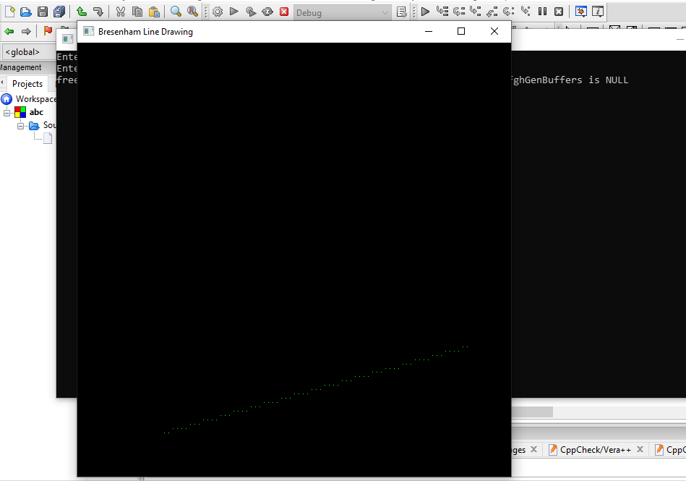
- Bhresenham’s Algorithm when m > 1
// Shafin Ahmed 232-15-184 65-M1
#include <GL/gl.h>
#include <GL/glut.h>
#include <stdio.h>
#include <stdlib.h>

float x0, y0, x1, y1;

void display()
{
glClear(GL_COLOR_BUFFER_BIT);
glColor3f(0.0, 1.0, 0.0);
glBegin(GL_POINTS);

int dx = abs((int)x1 - (int)x0);
int dy = abs((int)y1 - (int)y0);

int xc = (x1 > x0) ? 1 : -1;
int yc = (y1 > y0) ? 1 : -1;

int x = (int)x0;
int y = (int)y0;

glVertex2i(x, y);

// m > 1 er jonno Bresenham's Decision Parameter
int p = 2 * dx - dy;

while (y != (int)y1)
{
y += yc;
if (p < 0)
{
p = p + 2 * dx;
}
else
{
x += xc;
p = p + 2 * dx - 2 * dy;
}
glVertex2i(x, y);
}

glEnd();
glFlush();
}

void init()
{
glClearColor(0.0, 0.0, 0.0, 0.0);
glMatrixMode(GL_PROJECTION);
glLoadIdentity();
glOrtho(0, 100, 0, 100, -1, 1);
}

int main(int argc, char** argv)
{
printf("Enter First Point (x0 y0): ");
scanf("%f %f", &x0, &y0);

printf("Enter Second Point (x1 y1): ");
scanf("%f %f", &x1, &y1);

glutInit(&argc, argv);
glutInitDisplayMode(GLUT_SINGLE | GLUT_RGB);
glutInitWindowSize(600, 600);
glutInitWindowPosition(100, 100);
glutCreateWindow("Bresenham Line Drawing (m > 1)");

init();
glutDisplayFunc(display);
glutMainLoop();

return 0;
}
Output for : (20,20) , (30,60)
